DS 6373: Time Series: Unit 3 HW

Have a blast!

Problems from Chapter 2 of the Textbook:
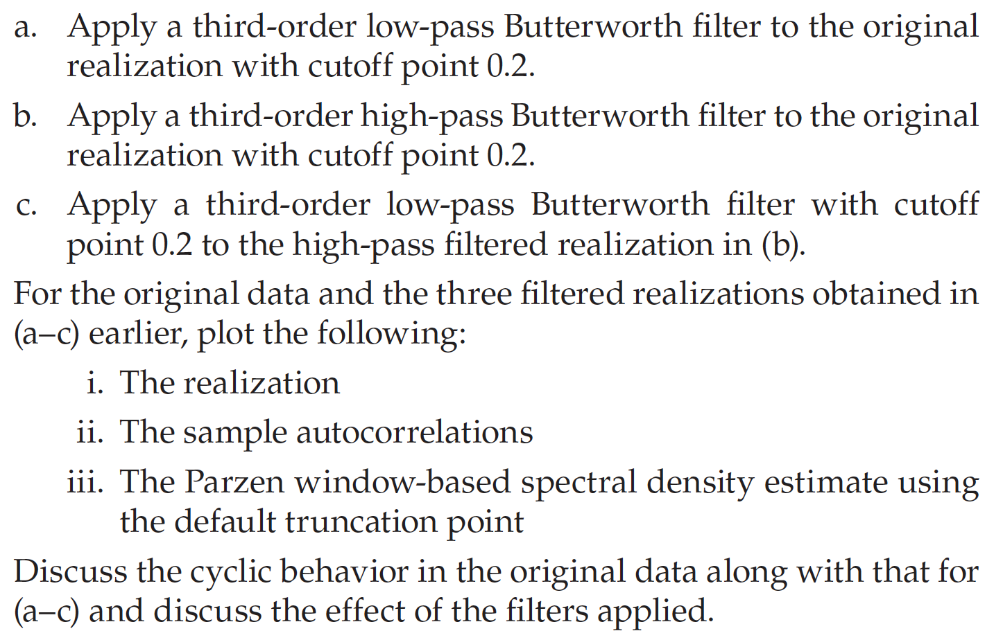
Additional Problem
Apply a 5-point moving average to the series you created in 2.1. How does it compare to the difference and Butterworth filters? Specifically, is it a low pass or high pass filter?

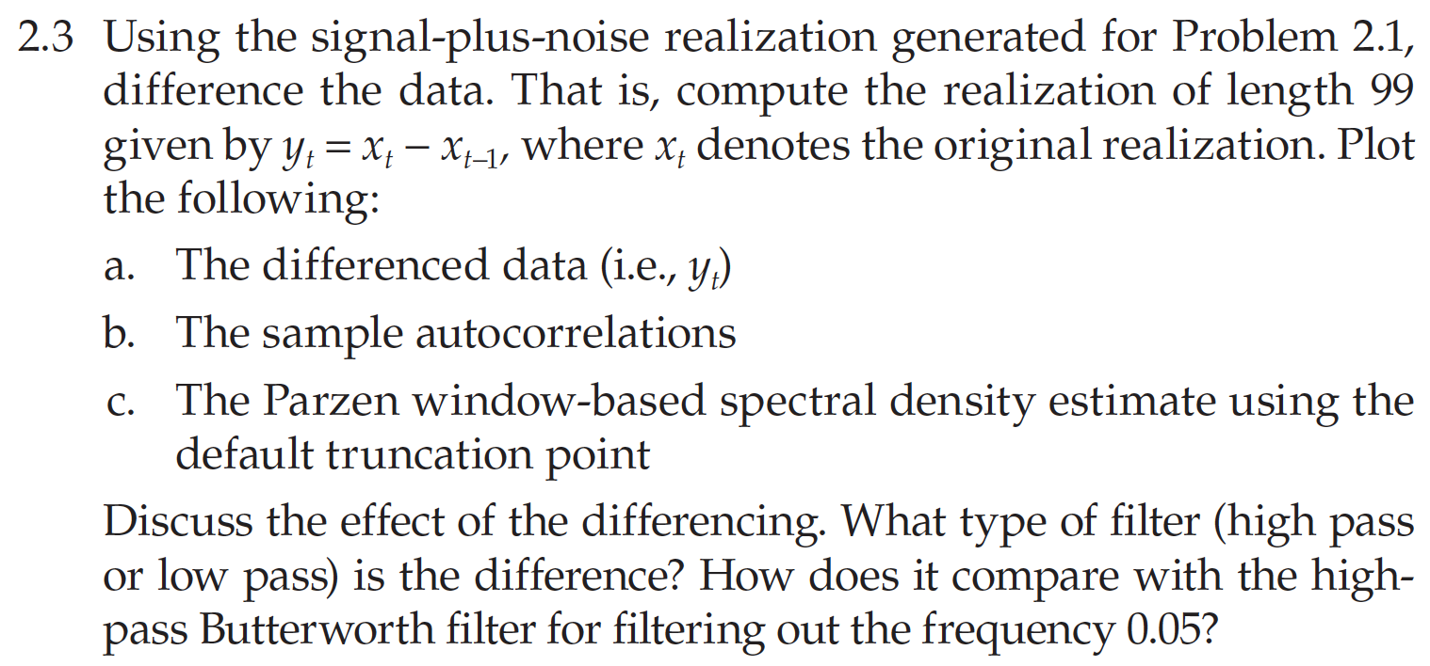

Problems from Chapter 3 of the Textbook:
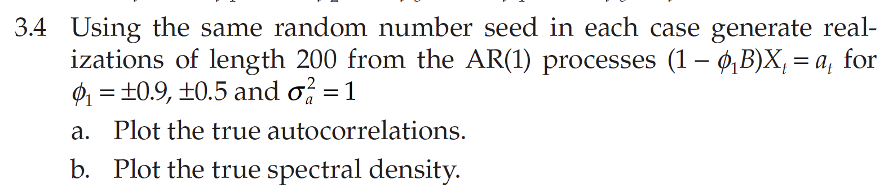
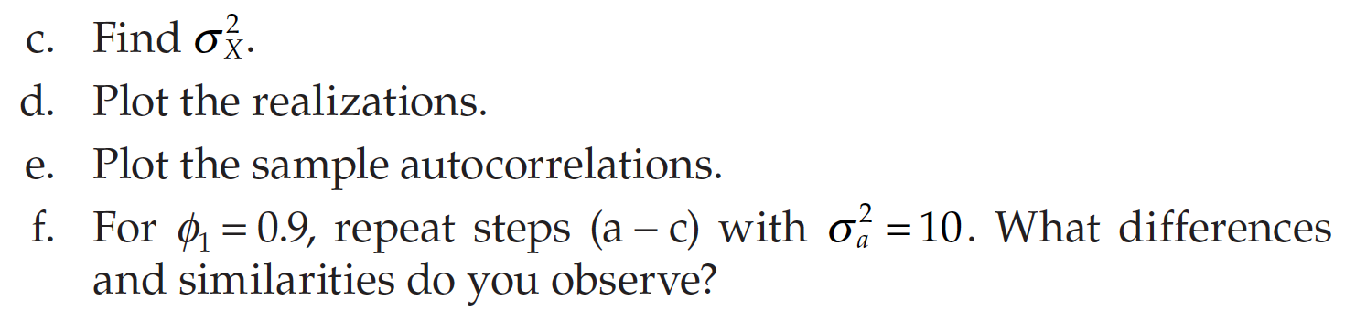

g. For $ϕ_{1}=.9$, write the characteristic polynomial, the characteristic equation, the roots of the characteristic equation and the absolute reciprocal of the roots of the characteristic equation.

h. Based on your findings in g… is this a stationary or non-stationary model? Why?

